Check the required modules

Purpose: Before executing the Python program, the below utility to ensure that the required modules are available.

Download checkmodule.py

<https://drive.google.com/file/d/1BXQkhHMHxL5Uz5zbMtgM9hTXz7OvtmWa/view?usp=sharing>

The program

required = {'pandas', 'numpy', 'beautifulsoup4', 'requests', 'bs4'}

import sys

from subprocess import run, PIPE, STDOUT

import pkg_resources

def run_cmd(cmd):

ps = run(cmd, stdout=PIPE, stderr=STDOUT, shell=True, text=True)

print(ps.stdout)

installed = {f"{pkg.key}=={pkg.version}" for pkg in pkg_resources.working_set}

missing = required - installed

if missing:

run_cmd(f'pip install --ignore-installed {" ".join([*missing])}')

Save at c:\python\temples\checkmodule.py

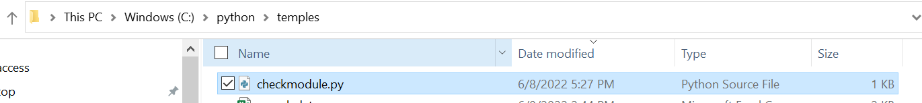

Execute

python checkmodule.py

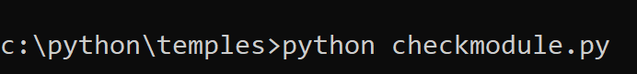

Result

c:\python\temples>python checkmodule.py

Collecting beautifulsoup4

Using cached beautifulsoup4-4.11.1-py3-none-any.whl (128 kB)

Collecting bs4

Using cached bs4-0.0.1-py3-none-any.whl

Collecting pandas

Using cached pandas-1.4.2-cp39-cp39-win_amd64.whl (10.5 MB)

Collecting numpy

Using cached numpy-1.22.4-cp39-cp39-win_amd64.whl (14.7 MB)

Collecting requests

Using cached requests-2.27.1-py2.py3-none-any.whl (63 kB)

Collecting soupsieve>1.2

Using cached soupsieve-2.3.2.post1-py3-none-any.whl (37 kB)

Collecting python-dateutil>=2.8.1

Using cached python_dateutil-2.8.2-py2.py3-none-any.whl (247 kB)

Collecting pytz>=2020.1

Using cached pytz-2022.1-py2.py3-none-any.whl (503 kB)

Collecting idna<4,>=2.5

Using cached idna-3.3-py3-none-any.whl (61 kB)

Collecting urllib3<1.27,>=1.21.1

Using cached urllib3-1.26.9-py2.py3-none-any.whl (138 kB)

Collecting certifi>=2017.4.17

Downloading certifi-2022.5.18.1-py3-none-any.whl (155 kB)

Collecting charset-normalizer~=2.0.0

Using cached charset_normalizer-2.0.12-py3-none-any.whl (39 kB)

Collecting six>=1.5

Using cached six-1.16.0-py2.py3-none-any.whl (11 kB)

Installing collected packages: soupsieve, six, urllib3, pytz, python-dateutil, numpy, idna, charset-normalizer, certifi, beautifulsoup4, requests, pandas, bs4

ERROR: pip's dependency resolver does not currently take into account all the packages that are installed. This behaviour is the source of the following dependency conflicts.

daal4py 2021.5.0 requires daal==2021.4.0, which is not installed.

anaconda-project 0.10.2 requires ruamel-yaml, which is not installed.

numba 0.55.1 requires numpy<1.22,>=1.18, but you have numpy 1.22.4 which is incompatible.

Successfully installed beautifulsoup4-4.11.1 bs4-0.0.1 certifi-2022.5.18.1 charset-normalizer-2.0.12 idna-3.3 numpy-1.22.4 pandas-1.4.2 python-dateutil-2.8.2 pytz-2022.1 requests-2.27.1 six-1.16.0 soupsieve-2.3.2.post1 urllib3-1.26.9